Burp Suite Setup and Guide

Guide/Background Information
Burp Suite is a tool used by cybersecurity professionals to test the security of websites and web applications. It helps you see, modify, and analyze the traffic (data) going between your browser and a website. Think of it as a middleman between your browser and the internet that lets you inspect what is being sent and received.

1. What Burp Suite Does (Simple Idea)
Normally when you visit a website:
Browser → Website Server → Response back to Browser
When using Burp Suite, the traffic goes through Burp first:
Browser → Burp Suite → Website Server
Because of this, Burp can:
- Capture requests your browser sends
- Show you the data being transmitted
- Let you modify requests before they reach the server
- Analyze responses from the server
This is extremely useful for finding vulnerabilities in web applications.
2. What It’s Used For
Security testers and ethical hackers use Burp Suite to test for issues like:
- SQL Injection -
- Cross-Site Scripting (XSS) -
- Authentication flaws -
- Session or cookie vulnerabilities -
- Broken access control -
3. Important Burp Suite Components
Burp Suite has several built-in tools. The most common ones beginners use are:
1️⃣ Proxy
The Proxy is the main feature.
It:
- Intercepts HTTP/HTTPS requests
- Shows exactly what your browser sends
- Lets you modify the request before forwarding it
Example intercepted request:
POST /login HTTP/1.1
Host: bank.com
username=admin&password=test

2️⃣ Repeater
The Repeater lets you resend the same request multiple times with changes.
Security testers use this to:
- Test different inputs
- Modify parameters
- Experiment with payloads
Example:
- Change password=test
- Try password=' OR 1=1--

3️⃣ Intruder
The Intruder automates attacks.
It can:
- Send many requests quickly
- Test large lists of payloads
- Perform brute force attacks on forms
Example uses:
- Password brute forcing
- Fuzzing parameters
- Finding hidden vulnerabilities
4️⃣ Decoder
The Decoder helps convert data formats.
Examples:
- URL encoding
- Base64
- HTML encoding
Useful when analyzing obfuscated or encoded data.

Example Real Scenario – What we are doing with BtB
Imagine testing a banking website login.
Without Burp:
- You type credentials
- Browser sends request
- Server responds
With Burp:
- Login request is intercepted
- You inspect the parameters
- You modify them
- Send modified request to the server
This allows testers to find vulnerabilities like:
- authentication bypass
- parameter tampering
- insecure cookies

Setup Guide
This part must be done to connect to our Website with Burp Suite. Do this before installing Burp Suite
*Makes sure to install Burp Suite on the same Virtual Machine you have the BtB Website installed on too.* This is because our website is a local host and Burp Suite needs to be on the same system as the website to capture information about our website.
Configuring Correct Network Settings Guide
Step. 1
Open Firefox on your Virtual Machine
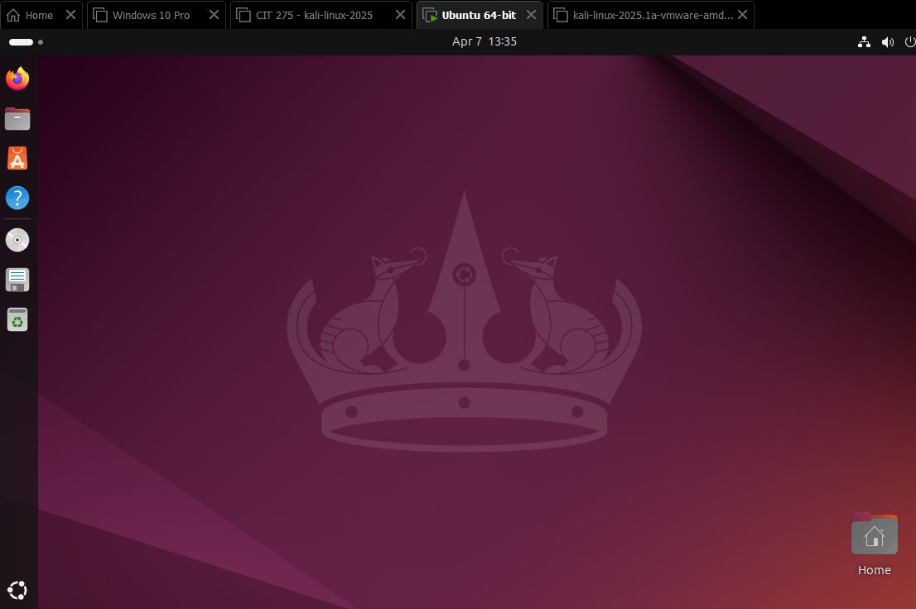

Step 2.
In Firefox go to the Settings by clicking on the three lines in the corner and clicking on Settings, then go to the General Section.
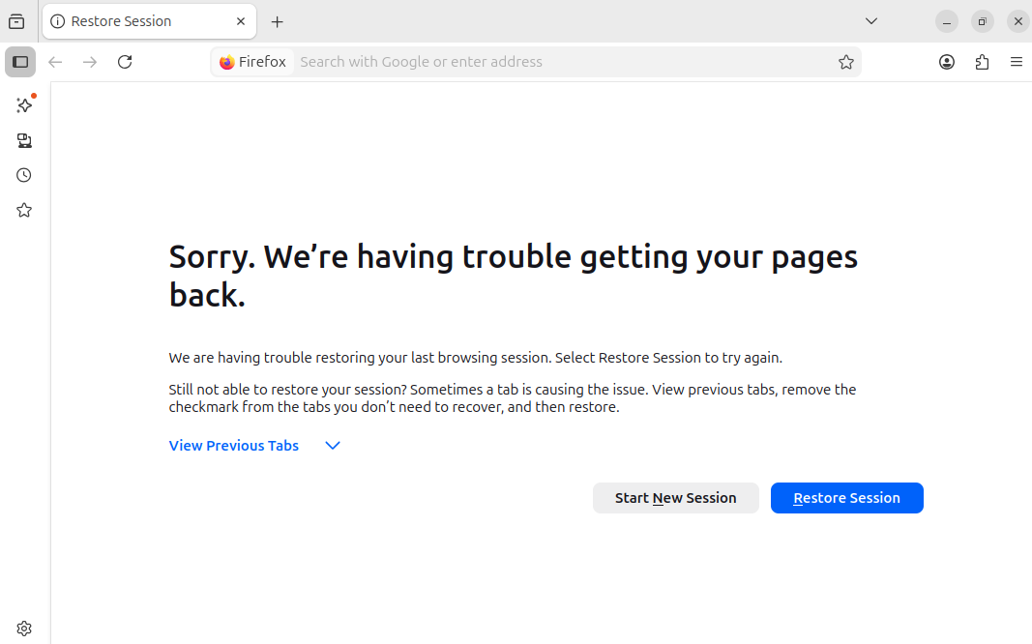
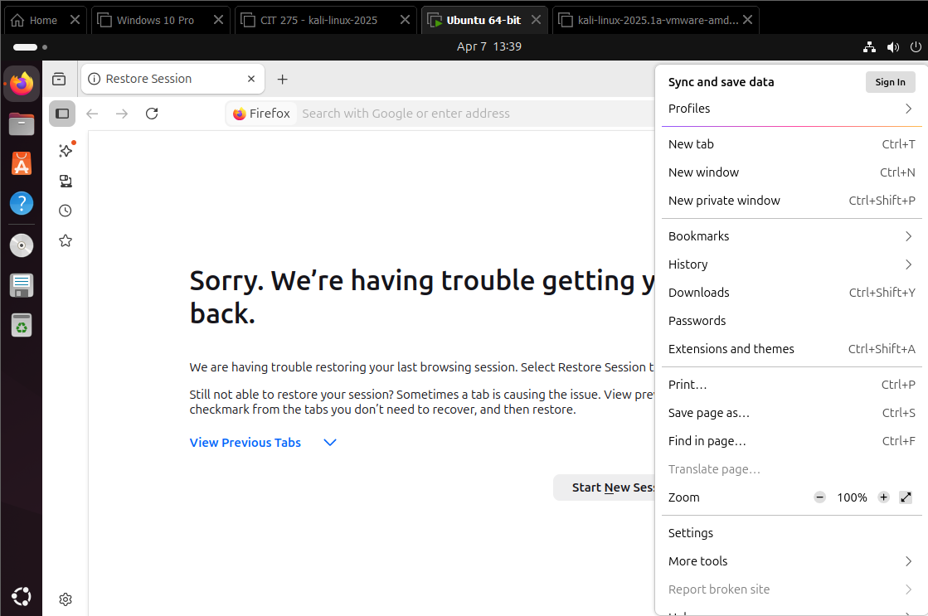
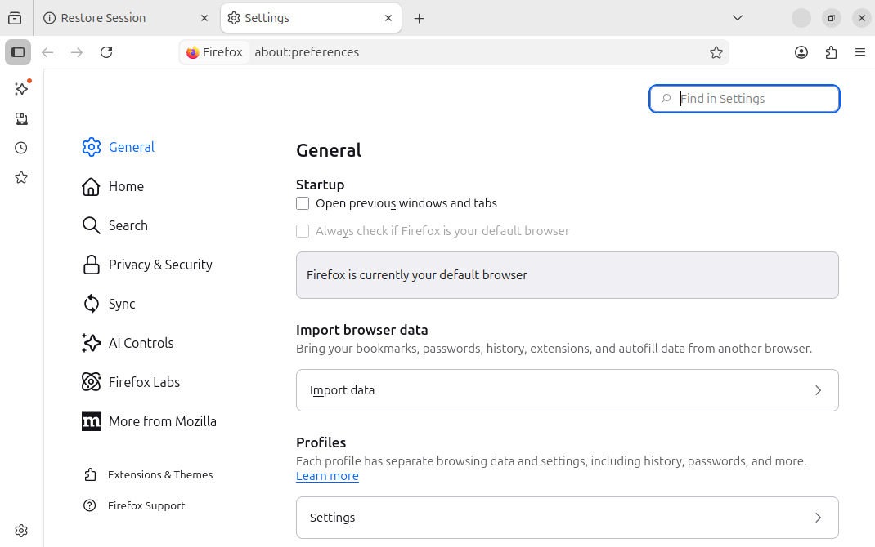

Step 3. Scroll down to the bottom of the General Section, click on the Settings tab to configure network settings.
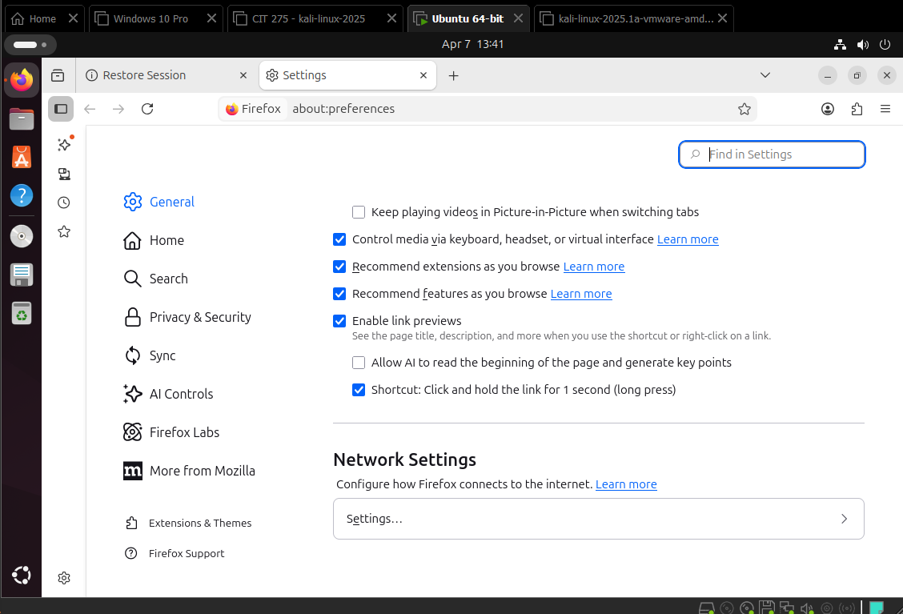

Step 4. Select Manual Proxy Configuration, type in 127.0.0.1 in the HTTP Proxy, and 8080 in the Port Section. Select OK once settings are finished. Beware Configuring this setting will make it seem like the interconnection is not working I noticed. So if you need to access the internet on a website like YouTube from your virtual machine, reset the Network Settings to what they were before by selecting No Proxy and saving that setting.
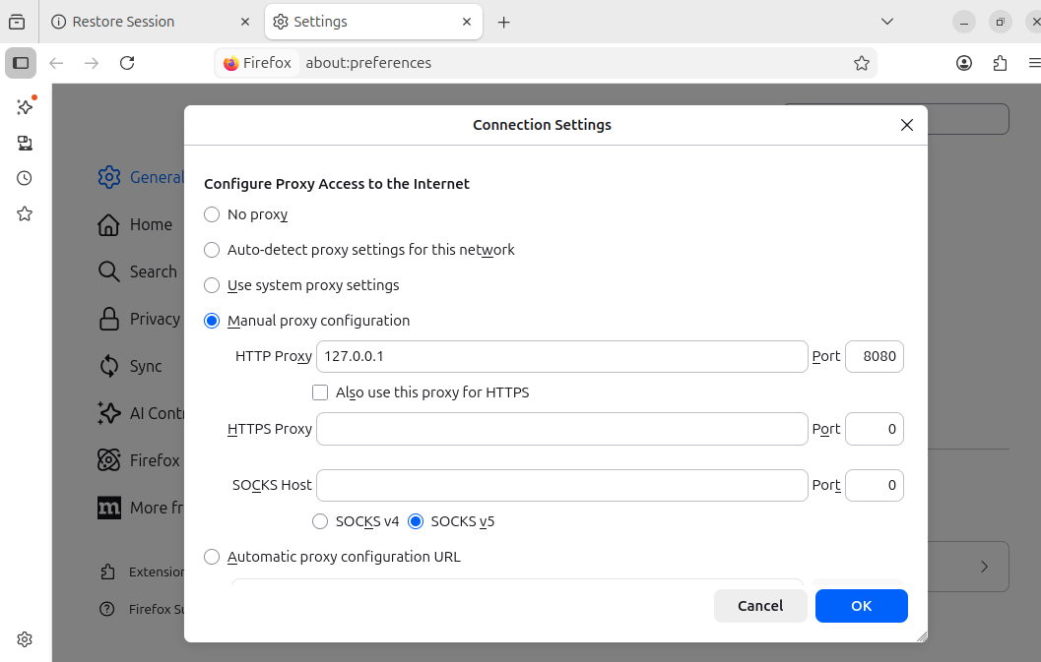

Watch Installation Video to see process - (320) How to Install Burp Suite on Linux (Ubuntu, Kali Linux, etc.) - YouTube
This link explains it well in a step by step guide - https://www.geeksforgeeks.org/installation-guide/how-to-install-burp-suit-in-linux-system/
Video on how to use Burp Suite - https://www.youtube.com/watch?v=zHBpJA5XfDk&t=29s

